**Use reduce side join to join the two datasets and find What kind of problems are prevalent, and in which state?**

Driver :-

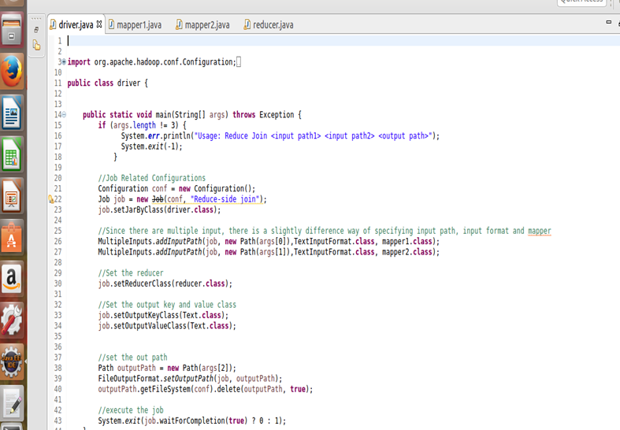

Mapper 1:-

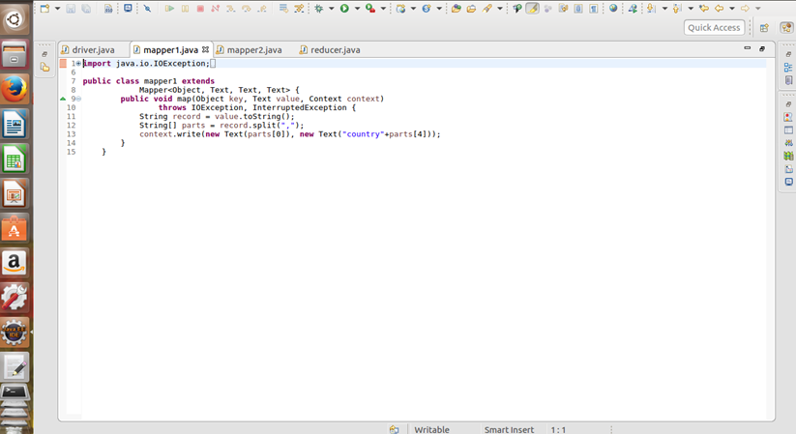

Mapper 2:-

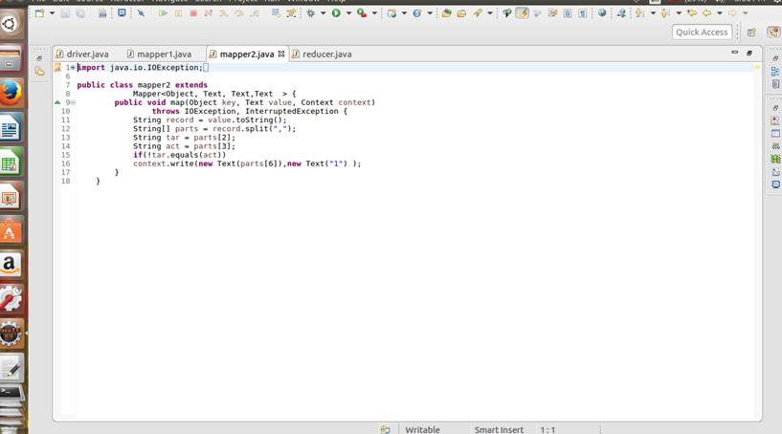

Reducer:-

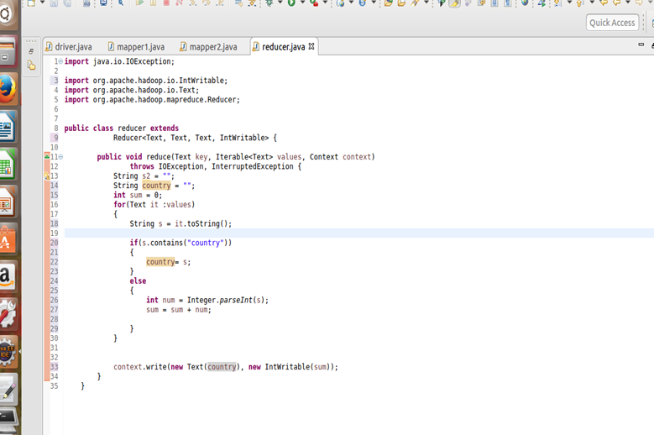

Output:-

